Comm Ethics Final (Kohner PR)
Jacob Kohner
Dr. Dool
Communications ethics 548
12/9/2025

In an age headlined by continuous access to information, organizational scrutiny, and high public expectations for integrity, PR firms have become crucial as they are the intersection between communication, reputation, and responsibility. Kohner PR is a newly founded public relations firm that is committed to elevating ethical standards and promoting transparent and data driven communication practices. This paper will elaborate a comprehensive ethical framework for the company, expanding on concepts and demonstrating how our foundational ethical philosophy translates into every facet of the organization such as internal systems, external communication practices, or strategies engaging with stakeholders and ensuring long term accountability. This plan is designed to give a blend of the ethical theory that was discussed in class and mix it in with applied practices that a company under my watch would apply to its everyday operations. Using this ethical foundation Kohner PR looks to establish itself as a leader in public relations.
Kohner PR will specialize in providing communication support and reputation management for clients in commercial, nonprofit and government sectors with a separate division focusing on PR in the athletic industry. Central to the firm’s identity is its mission to deliver PR solutions that are ethical, create trust, support accountability, and strengthen relationships with all stakeholders. Core values at Kohner PR are three simple words trust, transparency, and timeliness. These three core values serve as a guiding principle in both strategic decision making and everyday operations. Additionally, the firm has implemented a formal code of conduct that sets clear expectations for ethical behavior, creating an reference point for decision making. The purpose of Kohner PR is to champion honesty in communication by helping organizations articulate their messages rooted in truth aligned with the public’s right to accurate information. By emphasizing responsibility and values driven by public relations we position ourselves not merely as service providers but as servants of public trust in the broader communications landscape.
To help create an ethical foundation for the company we based some of our practices on principles that other public relations firms have established throughout the years. This framework can be found in the Public Relations Society of America (PRSA) code of ethics. They emphasize core values such as honesty, fairness, loyalty, advocacy, expertise, and independence, which guide all professional interactions and decision making. By adopting strategies like the free flow of information, transparency in communications, safeguarding confidential information, and avoiding conflicts of interest, Kohner PR ensures that its actions are both responsible and trustworthy. We commit to enhancing the profession on ethical decision-making and promoting accountability. We also encourage cross-departmental discussions and ethics audits to evaluate the effectiveness of our policies to identify areas for improvement. Integrating the standards helps build credibility with clients, creating a culture where ethical behavior is a cornerstone. (Here is a Chart from PRSA’s Website highlighting values at Kohner PR) 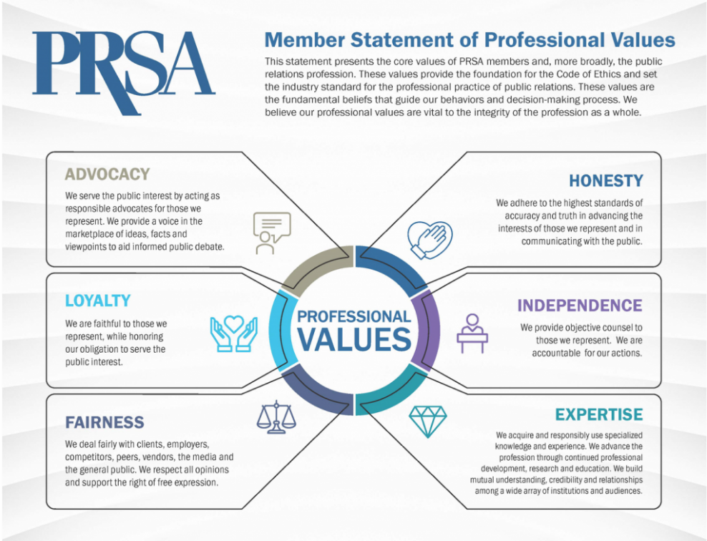
Developing an ethical foundation requires a clear understanding of the ethical philosophies and influences we learned throughout the course. Kohner PR draws primarily from two theories discussed in class to include utilitarianism and the stakeholder theory both of which emphasize societal benefit, collective wellbeing, and responsibility to groups beyond the scope of those you serve. Utilitarian ethics emphasize actions that result in the greatest good for the greatest number. Relating this theory back to public relations utilitarianism means prioritizing the long-term well-being of audiences, communities, and organizations over a period of time. Utilitarian thinking guides decisions about transparency, truth, and the avoidance of harmful manipulation. Stakeholder theory however expands moral consideration to all parties affected by communication strategies such as client employees, the media, the general public, regulators, and partner organizations. The company’s commitment to stakeholders’ well-being ensures that strategies avoid deception of misinformation or reputational harm to any of those involved. By combining these theories, Kohner PR develops a decision-making matrix that weighs both outcomes and stakeholder impact, giving us a structured approach to facing complex issues.
Although public relations can strengthen trust and support responsible communication, the industry also contains examples of harmful and unethical behavior. A firsthand account published in HuffPost describes working inside a PR firm that routinely misled clients, exaggerated achievements, and manipulated media narratives. This example demonstrates how unethical communication damages not only the public but also the employees who are pressured to carry out these practices. The firm’s behavior clearly violates both utilitarian and stakeholder ethics. In pursuing short-term wins, the organization disregarded the long term well being of audiences, journalists, and clients, ultimately contributing to public mistrust. Internally, the account reveals how weak ethical leadership created a culture where employees feel unable to voice concerns. For Kohner PR, this case highlights exactly what our ethical framework aim to prevent. The failures described reinforce the importance of truthfulness, accountability, and strong leadership. To avoid similar pitfalls, Kohner PR conducts leadership ethics workshops that include scenario-based training, emphasizing how managers can model ethical behavior even in stressful situations. This article shows why Kohner PR is committed to building systems and values that support honest communication and long-term trust.(HuffPost)
To further examine the leadership style Kohner PR integrates these core principles into its organizational culture. The firm emphasis mutual respect, valuing the contributions of employees at all levels. Leaders must model accountability by standing behind their decisions and addressing challenges to set the standard for their teams. The company prioritizes service, engaging in community initiatives and encouraging staff participation in volunteer work. Through honesty and clear communication, Kohner PR builds trust with clients and stakeholders, while a commitment to justice ensures fair treatment in policies and client relationships. By treating the firm as a community Kohner PR promotes inclusion, equity, and collaboration across all departments. (Kirk) (Below is a graphic from DR. Valeria highlighting these Points)
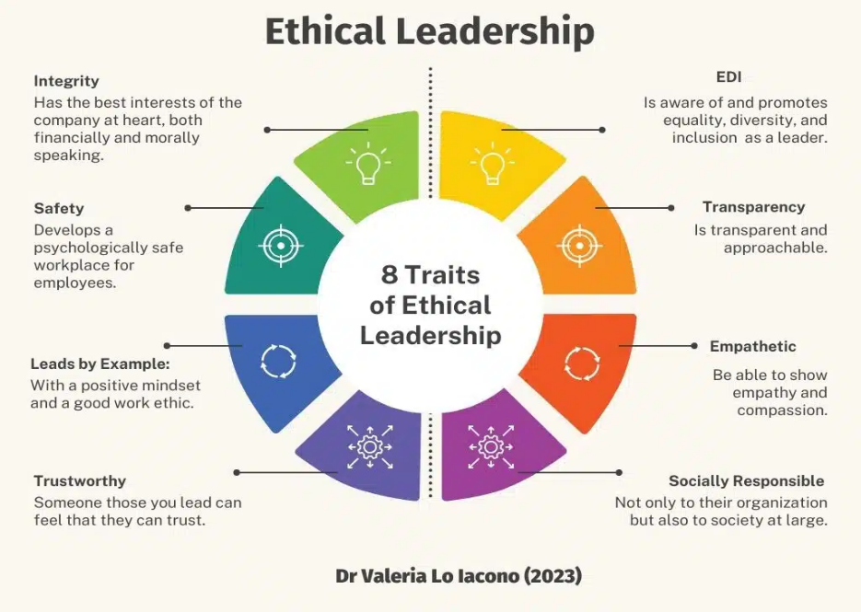
Kohner PR is derived by two principles that at its core underline the companies over all ethical vision that will help support our goals to create honest communication and long-term trust, the first being truth. All messages must reflect information that is both accurate and verifiable. Truth is the foundation of ethical public relations practices because the PR profession is one that is grounded in credibility and trust. When a firm commits to truthfulness it strengthens its ability to communicate effectively and serves as an honest intermediary between the organization and those that it serves. Truth builds and sustains credibility, protects public trust and mitigates risk. The other principle, transparency, is the idea that stakeholders must be able to understand the motivations, sources, and sponsorships behind communication. Transparency is essential because it ensures stakeholders have access to the information, they need to understand organizational actions intentions and impact. While truth is about accuracy transparency is about openness and willingness to share relevant information rather than obscuring it. Together, truth and transparency create a measurable ethical standard that can be tracked through client feedback, public sentiment analysis, and internal reports.
Our vision of this PR firm is simple. We encourage a communication style where honesty, accountability, and trust are at the heart of everything we do. We have a commitment to those we serve to resist manipulation and instead foster genuine relationships with our clients. To make sure that our ethical mission and vision come to fruition it must start at the top. Leadership at Kohner PR models professionalism empathy and clarity. Members of the executive team are responsible for setting transparent expectations both with our employees and clients as well as other constituents within the organization. Due to the high stress nature of the public relations industry, we encourage our employees to use ethical judgement in those high-pressure situations and that starts with modeling that behavior from the top down. We want employees to feel comfortable coming to executives in situations that they may feel are affecting them negatively and how we can best support them. This is especially true when it comes to potential ethical dilemmas such as conflicts of interest or inappropriate workplace conduct. Most importantly we want to ensure alignment with our company values and practices. A strong ethical tone among leadership ensures that our employees feel supported in making decisions that affect their performance. Creating a firm with these standards requires structures to guide behaviors, reinforce values, and ensure every team member understands their responsibilities and knows they are valued both professionally and personally.
Constantly ensuring that ethics training is an ongoing part of our organization rather than just a once-a-year requirement that employees check off their to-do list enables us to maintain the highest standards in this area. Parts of our ethics training systems include but are not limited to include workshops, case study reviews, role playing, and regular assessments to reinforce ideas. Inviting ethics into the onboarding process at Kohner PR helps establish early understandings of responsibilities and expectations. Areas that we discuss in these training are the following foundational policies are code of ethics and professional conduct, requirements for conflicts of interest disclosures, protocols on employee media relations, confidentiality and data protection, and crisis communication procedures. These policies allow for structure while creating flexibility for various client contexts.
One of our most important policies though is our whistleblower and reporting systems. The firm’s whistleblower policy is designed to protect employees who report unethical illegal or improper conduct. It guarantees anonymity, prohibits retaliation, and makes sure that each report is verifiably against company standards. Each incident reported through our system is investigated in a prompt manner. Kohner PR values the psychological safety of everyone that has a stake in our companies’ success. These policies are meant to strengthen trust with our constituents both internally and externally. The whistleblower policy is only one aspect of our internal communications strategy. Ethical communication is foundational to PR, and our company employs strategies that reinforce transparency and accuracy. To ensure everyone is on the same page within the organization we have weekly staff meetings within every department so that everybody meets face to face. We also use routine email updates at the end of each workday to delegate tasks and reiterate responsibility on a regular basis. Recognizing the importance of ethical leadership, employees are welcome to utilize an open-door policy for discussions with management especially regarding ethical concerns. We also have a dedicated intranet with clear policy documentation. This clear and internal communication prevents easy misunderstandings and ensures the messages we are delivering to our staff are consistent from the top point. We help our clients do the same externally with press releases, official websites, media statements, transparency reports, and corporate responsibility initiatives. All of our client’s work is reviewed for accurate clarity and ethical integrity before it is released to the public. We do this for three reasons honesty builds trust, clarity eliminates confusion, and transparency protects organizational credibility. These narratives reinforce the firm’s mission and identity while preparing clients to expect authentic messaging relevant to their industries.
At Kohner PR we recognize that marketing is a powerful tool, and our employees approach it with great responsibility. Our firm prioritizes accuracy in all messaging, avoiding exaggerations, omissions, and manipulative persuasion tactics. As it is understood through the organization that truthful communication is not only seen as a moral duty but as an essential quality for long-term public credibility. With this commitment another duty the firm has is a commitment to customer transparency within all stakeholder groups. Our customer transparency policies could be described in three simple steps. A customer first approach putting people before perception, committing us to open honest and accurate disclosure of all sponsorships, partnerships, and affiliations while being opposed to deceptive measures or hidden influences campaign styles. These customer transparency policies ensure that our audiences are never misled about the origin or intent behind anything or any piece of communication that Kohner PR is responsible for.
Engagement with our stakeholders no matter how big or small your role within our company goes beyond client relations and involves fostering responsible communication practices across the many communities we serve including but not limited to corporate clients, nonprofit partners, government agencies, our employees, media organizations, and the local communities that rely on them to give accurate and relevant information. As a firm we understand that each group has different expectations and responsibilities requiring tailored engagement approaches dependent on who we are responsible for dealing with. For example, if we are dealing with a corporate or nonprofit client, we will tailor our communication strategy to reflect the proper tone of the mission values for the issue that they serve. However, if we deal with a government agency, we understand that our tone may need to be more serious and direct. Our athletic clients may need to continue to evolve depending on individual circumstance so when dealing with those types of clients we may have to be more fluid. Either way Kohner PR will be up to the challenge.
Success in the industry is not possible without a dedicated and passionate staff who support our customers every step of the way. At Kohner PR we value diversity of thought and perspective and encourage employee feedback and participation whenever appropriate such as making sure employees have a voice and are invited to be an active participant in decision making when concerning company wide matters. Our employees work in a collaborative environment where feedback on messaging strategies is invited as it creates and cultivates a culture where questioning of strategy is viewed as constructive rather than demeaning or demoralizing to the team. Even though we work with several stakeholder groups and each department has its own responsibility, everybody is at least somewhat trained in dealing with any stakeholder group we serve. This promotes cross-different collaboration to ensure that multiple perspectives and personal feedback are valued and appreciated by everyone in the company.
There are three pillars of CSR for a public relations firm. The first being ethical communication that aligns with Kohner PRs core values of truth transparency and accountability. The second being community and social impact, the core focus is supporting and uplifting of the communities we serve such as working with nonprofits and partnering with local organizations. The third pillar is managing sustainable operations which core focus is environmental and organizational sustainability. As a PR firm we are committed to the community and prioritizing corporate social responsibilities through initiatives such as promoting truthful communication practices which means avoiding misinformation, deceptive or fabricated content as well as partnering with other organizations that share our values. We also believe in helping to fix issues instead of ignoring them. We provide special programs for media literacy education for the outlets that we believe don’t align with our overall mission and values. We believe everyone deserves a second chance to regain and strengthen their public credibility. These efforts align with the firm’s ethical vision and strengthen our own public credibility.
Ethical performance cannot rely on intentions alone. As a firm we must put actions behind our words and that requires measurable accountability. Here are some of the metrics and key performance indexes that we use to assess ethical success. These include but are not limited to annual employee trust and ethics surveys, stakeholder feedback forms, internal audits of our communication practices, internal tracking of reputation through measurements of overall public sentiment, and regular review of ethical breach reports to make sure we are constantly improving ourselves. These tools enable our ongoing improvement and ensure that ethical commitments translate our real-world behavior.
At Kohner PR we have strict timelines and milestones to make sure that we are on the right track however these timelines can vary depending on client needs and concerns. The internal schedule we would like to maintain includes quarterly company-wide ethical training, policy review sessions every six months, annual stakeholder ethics surveys, and continuous review of company-wide communication strategies. These timelines create predictable check points for reflecting on companywide progress and updating our process when necessary.
In conclusion Kohner PR is built on a commitment to ethical communication supported by strong philosophical foundations, clear internal structures, and transparent engagement strategies by prioritizing our core values of truth, transparency, and stakeholder wellbeing this firm position itself to meet the growing demand for ethical public relations in the ever evolving and complex communication environment and overall landscape. This paper outlined how ethical philosophies can be integrated into every facet of our operations providing a successful blueprint for a PR firm that is rooted in ethical integrity with a commitment to building long term trust and credibility in the industry.

References
Kirk, V. (2024, April 18). What is ethical leadership and why is it important? Harvard Division of Continuing Education. https://professional.dce.harvard.edu/blog/what-is-ethical-leadership-and-why-is-it-important/professional.dce.harvard.edu
HuffPost. (2016, October 24). What I learned from working for an unethical PR firm. HuffPost. https://www.huffpost.com/entry/what-i-learned-from-working-for-an-unethical-pr-firm_b_580fbbdee4b0f14bd28bd03c
Public Relations Society of America. (n.d.). PRSA Code of Ethics. PRSA. https://www.prsa.org/professional-development/prsa-resources/ethics#code

